**Check if python works in Command Line (CMD)**

1. *Open CMD*

a) Press Windows Button on your keyboard – (The Button between CTRL and ALT) – and the windows menu should pop up.

b) Type CMD

c) Press ENTER

**If you have done step one correctly the following window should have opened on your screen**

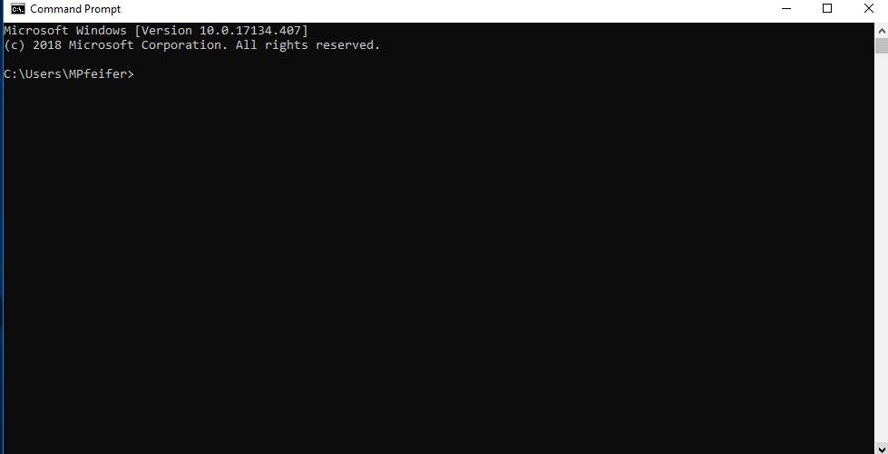

Figure (1)

1. Type *python* and then press ENTER. Please be aware you will get one of two messages.

Please note: DO NOT TYPE IT IN ALL CAPS OR CAPITALIZED (Python) – JUST python

* 1. Message 1 – figure (1)

Python 3.6.5 (v3.6.5:f59c0932b4, Mar 28 2018, 17:00:18) [MSC v.1900 64 bit (AMD64)] on win32 Type "help", "copyright", "credits" or "license" for more information.

>>>

* This means python has been properly installed and is working the way it should.
* Press CTRL-Z(Will appear as ^z) and press Enter – This will take you out of the python shell and back into cmd.
  1. Message 2– figure (3)

'python' is not recognized as an internal or external command,

operable program or batch file.

* This means python has **NOT** been properly installed and you should contact ilan about this.

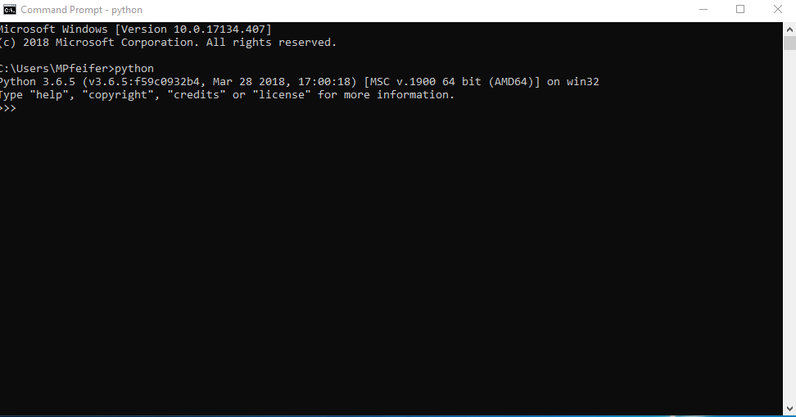 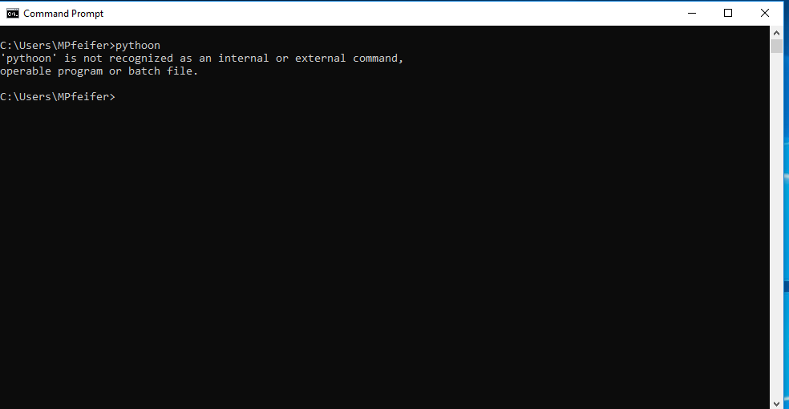 Figure (2) – Python works.

Figure (3) – Python not working

**Check if pip works in Command Line (CMD)**

1. *Open CMD*

a) Press Windows Button on your keyboard – (The Button between CTRL and ALT) – and the windows menu should pop up.

b) Type CMD

c) Press ENTER

**If you have done step one correctly the following window should have opened on your screen**



Figure(4)

1. Type *pip* and then press ENTER. Please be aware you will get one of two messages.

Please note: DO NOT TYPE IT IN ALL CAPS OR CAPITALIZED (Pip) – JUST pip

* 1. Message 1 – figure (5)

Usage:

pip <command> [options]

Commands:

install Install packages.

download Download packages.

……. …….

……. …….

* This means pip has been properly installed and is working the way it should.
  1. Message 2– figure (6)

'pip' is not recognized as an internal or external command,

operable program or batch file.

* This means pip has **NOT** been properly installed and you should contact ilan about this.

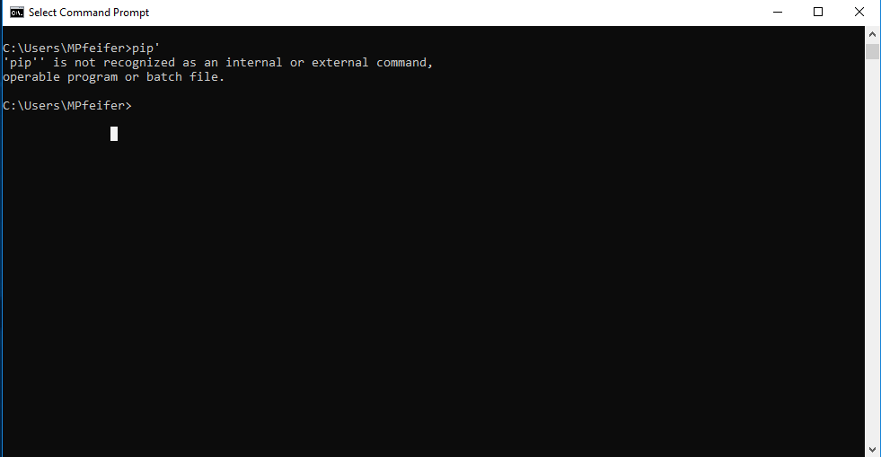 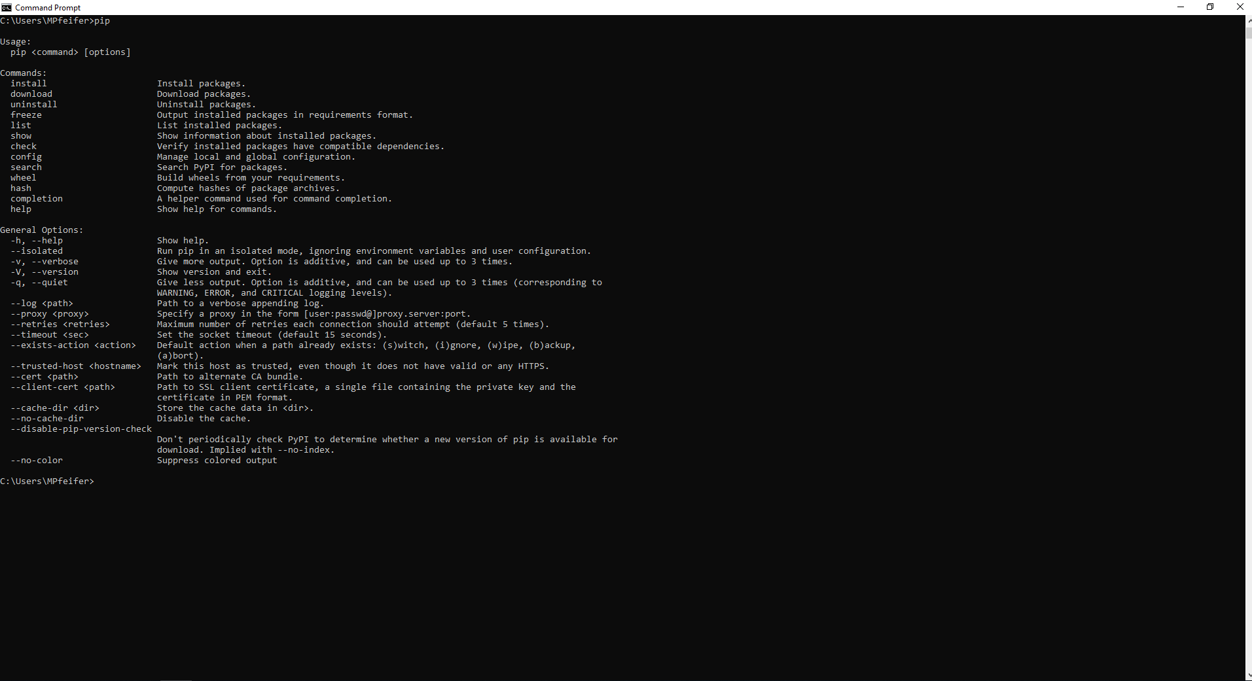 Figure (5) – Pip works

Figure (6)- Pip doesn’t work

**Check if Remaining Applications are installed properly**

**1) Notepad++**

a) Press Windows Button on your keyboard – (The Button between CTRL and ALT) – and the windows menu should pop up.

b) Type notepad++

c) Press ENTER

If an application appears then it is installed properly

**2) Sublime**

a) Press Windows Button on your keyboard – (The Button between CTRL and ALT) – and the windows menu should pop up.

b) Type sublime

c) Press ENTER

If an application appears then it is installed properly

**3) putty**

a) Press Windows Button on your keyboard – (The Button between CTRL and ALT) – and the windows menu should pop up.

b) Type putty

c) Press ENTER

If an application appears then it is installed properly

**4) pgadmin 4**

a) Press Windows Button on your keyboard – (The Button between CTRL and ALT) – and the windows menu should pop up.

b) scroll through your applications to the PostgreSQL folder - Figure (7)

c) click on the dropdown menu and a list of applications should appear – Figure (8)

d) click in the application called “PGADMIN 4”

* Make sure the application loads in you default browser (It may take a while) – Figure(9)
* If you don’t see the PostgreSQL Folder or get an error message email ilan.

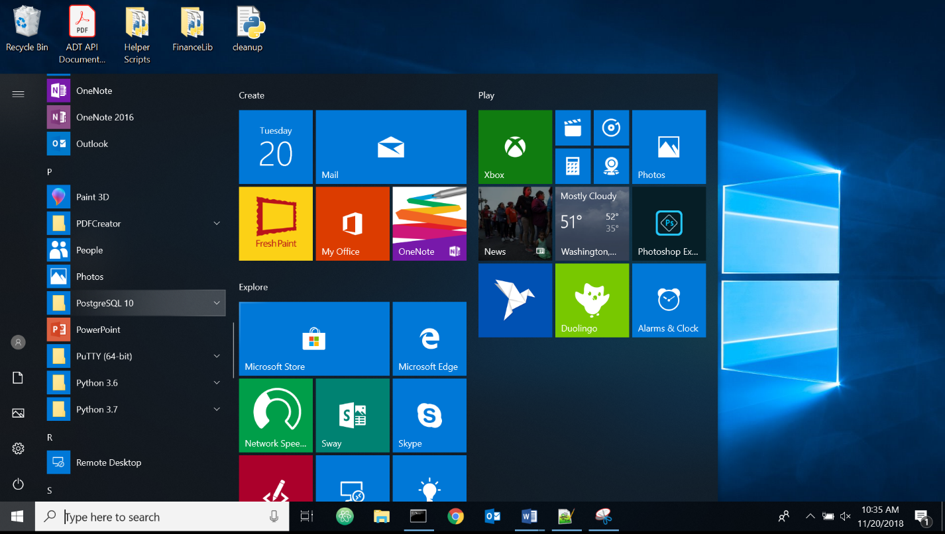

Figure(7)

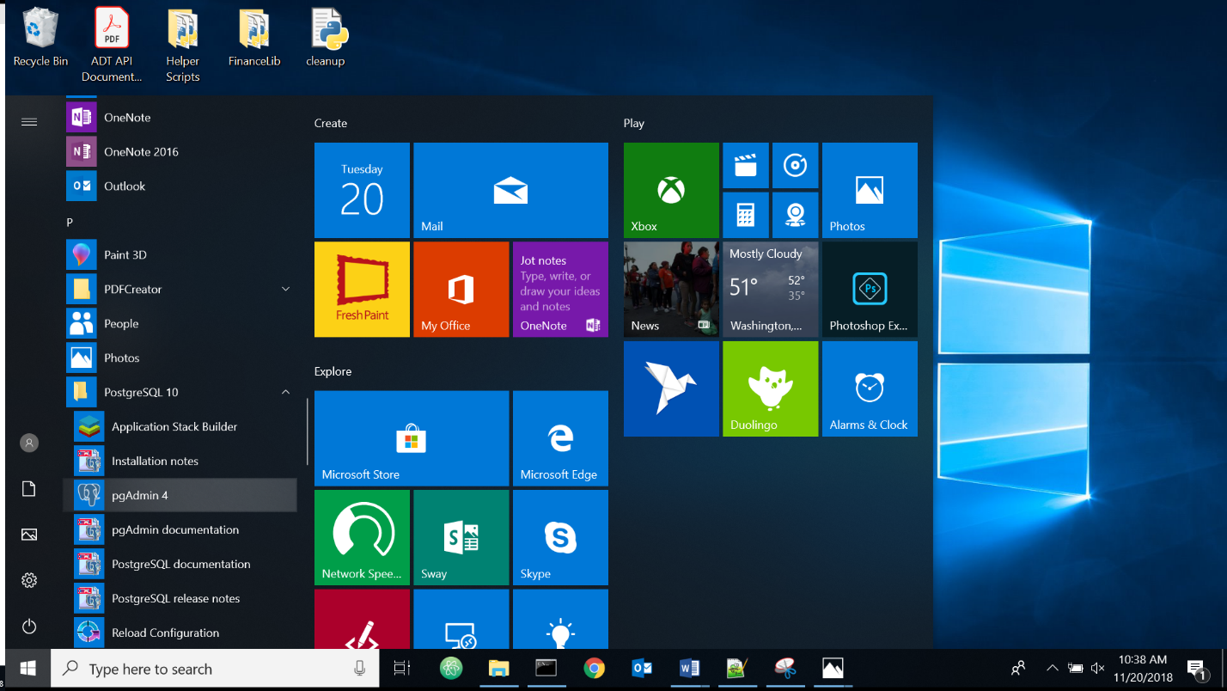

Figure(8)

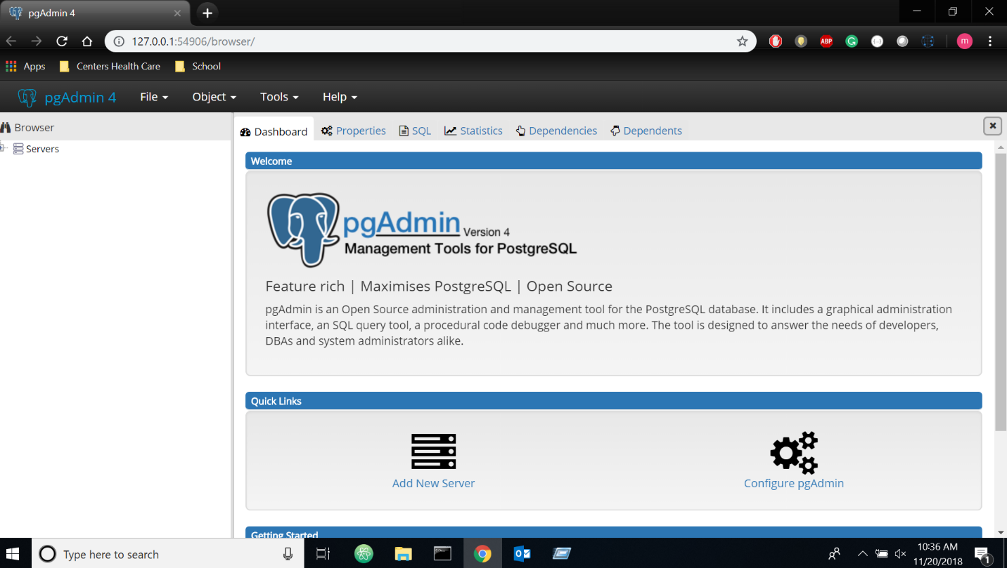

Figure(9)